**How to Use the Code Editor**

1. Select the "Run Code" button to execute the program.
2. Select the "Calculate Grade" button to generate a score based on the completed tasks.
3. Continue to modify, run, and calculate your code until you are happy with the grade.
4. Select the "Submit" button to turn in the assignment to your instructor.

**MySQL Lab Instructions**

1. Before running queries, check the selected database matches the database indicated in the instructions.
2. The "Run Code" button will run the contents of the *query.sql* file only.
3. Complete each task in order and press the *Run Test* button for that specific task before moving on.
4. Only select “Calculate Grade” when you are satisfied with your answer.

**Database Model: KimTay**

The management of KimTay Pet Supplies (a supplier of pet supplies, food, and accessories located in Cody, Wyoming) has determined that the company’s recent growth no longer makes it feasible to maintain customer, invoice, and inventory data using its manual systems. In addition, KimTay Pet Supplies wants to build an Internet presence. With the data stored in a database, management will be able to ensure that the data is up-to-date and more accurate than in the current manual systems. In addition, managers will be able to obtain answers to their questions concerning the data in the database easily and quickly, with the option of producing a variety of useful reports.

The CUSTOMER table maintains information about each customer, such as their ID, first and last name, address, balance, and credit limit.

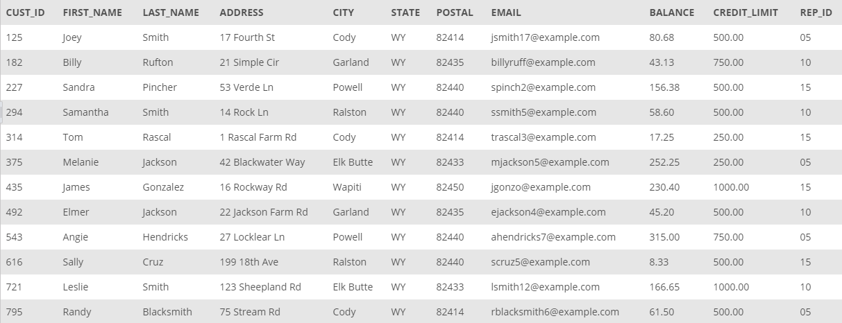

*CUSTOMER table*

In the INVOICES table contains information about each invoice, such as the invoice number, date, and the customer being invoiced.

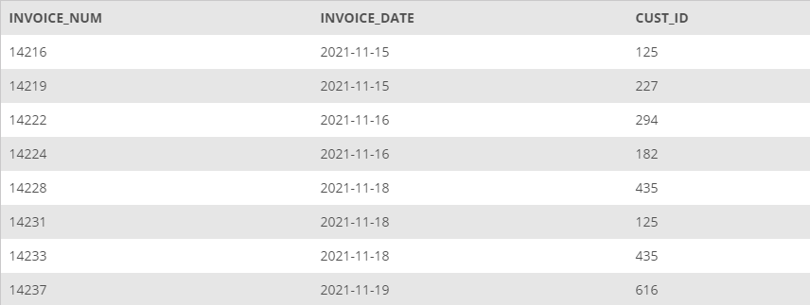

*INVOICES table*

The INVOICE_LINE table has the itemized information for each invoice. This includes the item ids, quantity, and price for each invoice.

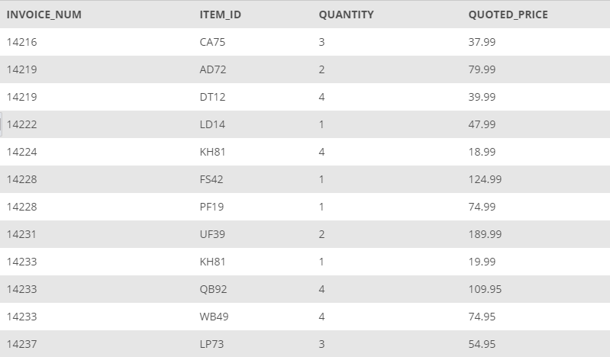

*INVOICE_LINE table*

The ITEM table has a information pertaining to each item for sale by KimTay's Pet Supplies. This includes a description, the number in stock, location, and price.

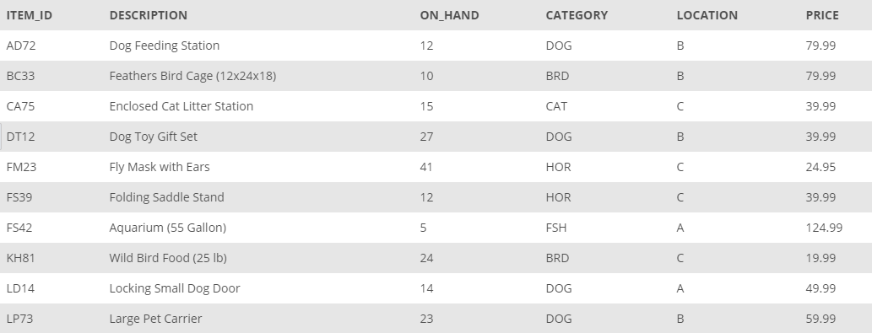

*ITEM table*

The SALES_REP table includes the information for each sales representative for KimTay's Pet Supplies. This includes first and last name, address, cell-phone, commission, and commission rate.

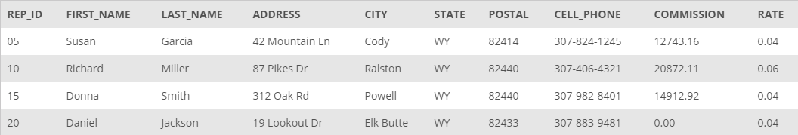

*SALES_REP table*

**Task 1:** For each invoice, list the invoice number and invoice date along with the ID, first name, and last name of the customer for which the invoice was created.

**Task 2:** For each invoice placed on **November 15, 2021**, list the invoice number along with the ID, first name, and last name of the customer for which the invoice was created.

**Task 3:** For each invoice, list the invoice number, invoice date, item ID, quantity ordered, and quoted price for each invoice line that makes up the invoice.

**Task 4:** Use the IN operator to find the ID, first name, and last name of each customer for which as invoice was created on **November 15, 2021**.

**Task 5:** Repeat *Task 4*, but this time use the EXISTS operator in your answer.

**Task 6:** Find the ID, first name, and last name of each customer for which an invoice was not created on **November 15, 2021**.

**Task 7:** For each invoice, list the invoice number, invoice date, item ID, description, and category for each item that makes up the invoice.

**Task 8:** Repeat Task 7, but this time order the rows by category and then by invoice number.

**Task 9:** Use a sub-query to find the sales rep ID, first name, and last name of each sales rep who represents at least one customer with a credit limit of **$500**. List each sales rep only once in the results.

**Task 10:** Repeat *Task 9*, but this time do not use a subquery.

**Task 11:** Find the ID, first name, and last name of each customer that currently has an invoice on file for Wild Bird Food (25 lb).

**Task 12:** List the item ID, description, and category for each pair of items that are in the same category. (For example, one such pair would be item FS42 and item PF19, because the category for both items is FSH.) Order the output by category.

**Task 13:** List the invoice number and invoice date for each invoice created for the customer **James Gonzalez**.

**Task 14:** List the invoice number and invoice date for each invoice that contains an invoice line for a **Wild Bird Food (25 lb)**.

**Task 15:** List the invoice number and invoice date for each invoice that either was created for **James Gonzalez** or that contains an invoice line for **Wild Bird Food (25lb)**.

**Task 16:** List the invoice number and invoice date for each invoice that was created for **James Gonzalez** and that contains an invoice line for **Wild Bird Food (25lb)**.

**Task 17:** List the invoice number and invoice date for each invoice that was created for **James Gonzalez** but that does not contain an invoice line for **Wild Bird Food (25lb)**.

**Task 18:** List the item ID, description, unit price, and category for each item that has a unit price greater than the unit price of every item in category CAT. Use the ALL operator in your query.

**Task 19:** For each item, list the item ID, description, units on hand, invoice number, and quantity ordered. All items should be included in the results. For those items that are currently not on an invoice, the invoice number and quantity ordered should be left blank. Order the results by item ID.

**Task 20:** Repeat *Task 18* using the ANY operator.

**Task 21:** For each sales rep, list the ID, first name, and last name for the customer, along with the sales rep first name, and sales rep last name. All reps should be included in the results. Order the results by rep ID.